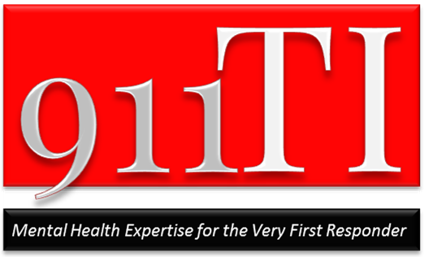

* **SNC: MCI201509A, approved for Module II(a) or Module III**
* **CLASS FEE: $229 per person**

About the Course Instructor

Jim Marshall, M.A., L.L.P., is the Director of the 911 Training Institute and a leading voice in the 9-1-1 industry for dispatcher wellness. He has been a licensed mental health professional for over 30 years. Jim is co-editor of The Resilient 9-1-1 Professional: A Comprehensive Guide to Surviving & Thriving Together in the 9-1-1 Center. Jim's courses, presentations, pilot projects, and published works equip 9-1-1 telecommunicators and their PSAP leaders to achieve optimal health and performance as people and organizations in the evolving 9-1-1 center.

***“Not the typical DV class.”***

This is a one-day, 8 hour course that can *make a career’s worth of difference* in how you feel about & deal with DV calls! You’ll gain fresh knowledge and powerful skills to master one of the most common yet dangerous call types for everyone on the scene.

* Become psychologically prepared to build a powerful connection with DV callers—the alleged victim and the *Intimate Terrorist*
* Boost your success & lower your frustration as the *Very First Responder*
* Learn best-practice DV Call Assessment skills to increase safety for all on scene
* Gain intervention skills to optimally manage DV calls and influence better outcomes
* Exchange mistaken beliefs about DV callers that fuel judgments with *fascinating new insights* to peak perform and boost your resilience

**Praise for “Managing DV”**

"Another quality class taught by Marshall. Time and training dollars well spent!”

“Another great 911 TI Class. Very informative & timely material. I really enjoyed the balance of clinical info/case studies & actual calls & discussion.”

“This is not the typical DV class. Excellently developed. Jim’s classes are the best in the business.”

**DATE & LOCATION:**

Hosting Opportunities are available to PSAPs in and beyond the U.S.

Visit our website to view current dates & locations

**TO REGISTER:**

**E-mail:**

info@911training.net

**On-line:**

[www.911training.net](http://www.911training.net)

**Phone:**

231-622-1600

9-1-1Pros! It’s time to Join Jim Marshall for…

# *Peak Performance in*

# Managing Domestic Violence Calls!™

# 

911 Training Institute│ 231.622.1600│ [info@911training.net](mailto:info@911training.net) │www.911training.net