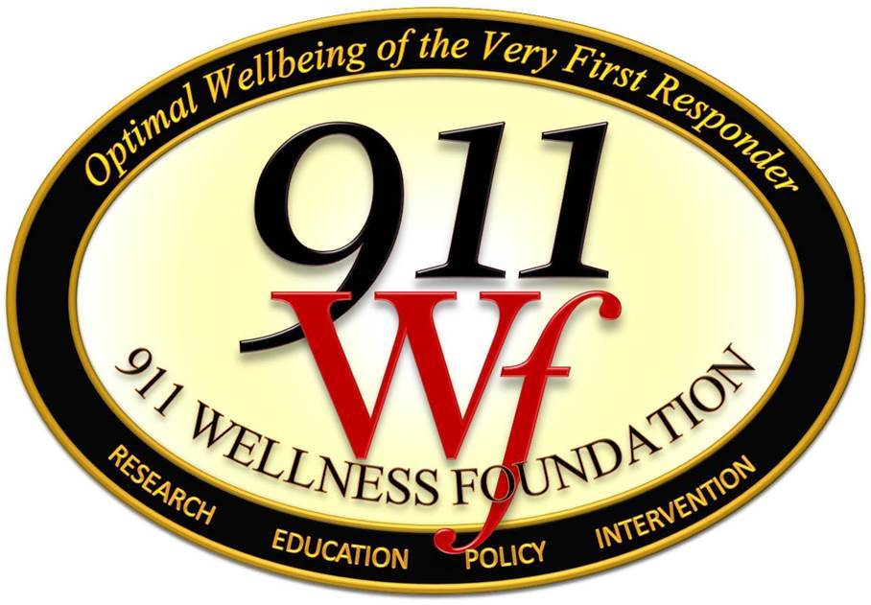

Assuring Best Practice in Delivery of Mental Health Services to 911 Employees

- INTRODUCTION

The Premise: 911 telecommunicators collectively represent what is called a special treatment population: such populations are composed of individuals who share specific characteristics that must be recognized and accommodated by the clinician if assessment and treatment are to be effective. Other special treatment populations include military personnel, police officers, survivors of mass casualty events, certain indigenous people groups, etc. The value of recognizing such groups is that their members are known to struggle with certain mental health problems at a greater rate and with different underlying issues compared to the general population; and members of a special population may have particular beliefs and views related to mental health services that increase their ambivalence about accepting help. Thus, they are at greater risk of not receiving the services they need because they are less apt to seek them and or because mental health providers are not equipped to treat them effectively.

These considerations about special treatment populations apply to 911 employees and must serve as the foundation for your agency’s decisions in selecting the clinical providers and organizations that will be tasked with caring for these personnel. The 911 employee’s ability to accept and participate in mental health services will require that selected clinicians have an understanding of their distinct culture and be qualified to treat the mental health issues to which they are especially at risk.

911 as part of the Law Enforcement Culture. The 911 profession is a subculture of the nation’s Law Enforcement Agencies (LEAS, in which 90% of our 911 centers are still housed). Law Enforcement Officers (LEO) and 911 telecommunicators share a skepticism of mental health due a stigma perpetuated in this culture summed up in the motto: mental health services are for the weak and are not likely helpful. Police and 911 professionals (“911Pros”) both often expect that non-emergency responder personnel from such agencies will not “get what we go through”—a belief that is unfortunately often confirmed when they attempt to seek help from well-meaning clinicians who do not specialize in treatment of first responders and miss the mark in their care responses. The stigma and belief noted here are then perpetuated when such treatment failures occur since these emergency responders, as members of any close-knit group, will talk about their experience (selectively), leading to underutilization of services.

911 as its own culture. In addition to these shared characteristics shared by LEOs, 911 is also its own group possessing very distinct characteristics. While 911 professionals share an increased risk of Post Traumatic Stress Disorder with LEOs, they appear to have a significantly higher rate of PTSD than LEO and firefighters. This has obvious and major implications for the foci of clinical assessment. It is also a key factor related to another distinction of the 911 community: telecommunicators have experienced a long history during which their role as the Very First Responder has been largely undervalued despite their extraordinary exposure to traumatic events. As a result, 911Pros are especially sensitive to how their profession is perceived by those outside their profession, including mental health professionals. So, during an initial session when seeking help for work-related stress issues, the telecommunicator is inclined to quickly dismiss a clinician viewed as ignorant about the 911 profession and that lacks knowledge or at least a humble curiosity about stressors unique to 911 telecommunicators. The clinician treating these professionals must be psychologically prepared to tolerate extremely emotionally impacting material common in telecommunicators’ work experience.

Summary and Implications. It is an ethical responsibility of the 911 center leadership, whenever possible, to seek contractual relationships with those clinicians who are qualified to treat 911 telecommunicators. Standard assessment and treatment delivered by a competent generalist clinician will typically not be effective, leading to a low participation rates in clinical services by personnel, a higher rate of treatment failure when completed, and thus also a higher risk of ongoing stress-related problems impacting personal health, professional performance and the well-being of the 911 center culture. This information can help 911 leaders tasked with selection and evaluation of Employee Assistance Program (EAP) providers by defining criteria essential to their success as discussed further below.

II. best practice in selection of Employee Assistance Plan (EAP) Providers

The purpose of an EAP in contractual relationship with a 911 center is to provide initial mental health and counseling services at no charge to the employee for a limited number of sessions to incentivize the employee to take initiative for self-care. The goal of such participation (which is strongly supported by research findings) is to prevent development and persistence of psychological problems negatively impacting work performance and retention. As a fundamental expectation of a typical EAP service contract, the provider organization agrees to serve as the first point of contact for employees in distress. So with initiation of a contractual relationship, all employees are informed of the available services, the terms by which those are delivered, and how the EAP can be contacted when needed. When a 911 employee elects to seek such services, we can expect that they are in an emotionally vulnerable state and likely ambivalent about openly acknowledging their psychological struggles.

Leader’s will be most likely to succeed in selecting an EAP if they keep this first critical moment of initial contact between their employees and a clinician in mind--and all that may be riding on it for the individual and the agency.

A Standard for Best Practice in Selecting EAP Providers. The 911 Wellness Foundation offers the following standard as a guide to assist leaders in securing an effective EAP provider for 911 as a Special Treatment Population.
911 centers should make every effort to identify and contract with an organization as the EAP provider that is adequately staffed by clinicians who:
- Specialize in the assessment and treatment of traumatic stress
- Possess expert knowledge about psychological resilience and related skills training
- Have extensive experience utilizing Evidence-Based Treatment (EBT) for PTSD
- Are knowledgeable (or willing, as a condition of their EAP contract, to become fully knowledgeable) about the distinct characteristics of the 911 profession and its culture, and the greater emergency response culture.

The Foundation recognizes that 70% of the nation’s 911 centers exist in rural areas where there is a limited availability of licensed mental health professionals, and an even smaller supply of clinicians with the qualifications set forth in this standard. Keep in mind that our shared goal is only and always to do our best in the context of the services available in given areas and that effectiveness of mental health services to 911 will depend on the extent to which this standard can be met.

For a thorough introduction for clinicians to the 911 culture and delivery of evidence-based treatment to this population, see Reaching the unseen first responder with EMDR therapy: Treating 911 trauma in emergency telecommunicators. Marshall, J., & Gilman Sara G. (2015). In M. Luber (Ed.), Eye Movement Desensitization and Reprocessing (EMDR) Therapy Scripted Protocols and Summary Sheets: Treating Trauma- and Stressor-Related Conditions (pp. 185-216). New York, NY: Springer Publishing Co.

CLICK HERE If you arrived at this document by hyperlink from the Post-Event Personnel Care Planner (PEPCP) and wish to return. For more information, email 911Wellness@live.com.

